National Writing Project UK

Teachers’ Writing Residential
Teachers’ writing groups transform practice

NWP’s 2nd writing residential course
for teachers, researchers and university lecturers who are interested in teaching writing

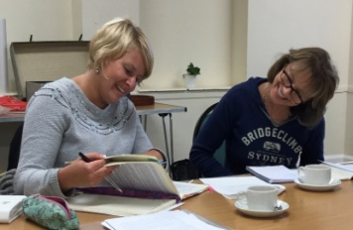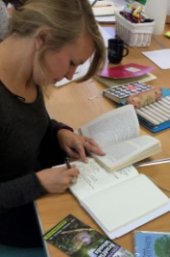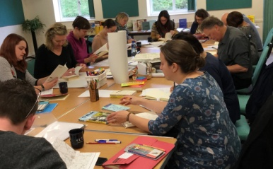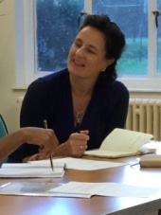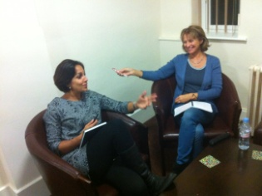

Wednesday 25th – Friday 27th October 2017

High Leigh Conference Centre,
Lord Street, Hoddesden, Hertfordshire
EN11 8SG

This innovative and forward-looking course is designed to provide the context for participants to deepen their knowledge and understanding of writing and writing pedagogy from the inside out.

There will be opportunities for participants to:
- write for themselves within a community of writers;
- deepen understandings of writing processes;
- understand the nature of writing and the ways in which it informs thinking and learning across the curriculum and
can be integral to pupils’ personal, social and spiritual development;
- extend understandings of pupil progress in writing;
- establish a principled understanding of pedagogy arising from research and the experience of teachers’ writing groups.

The course will be run by Dr Jenifer Smith and Simon Wrigley, authors of Introducing Teachers’ Writing Groups: exploring the theory and practice published by Routledge in 2015. They both have long experience of writing with teachers and children.

Cost: £205: en suite accommodation; good food; beautiful grounds; expert tuition. All participants will receive a study and resource pack.

To book a place please contact
jenifersmith1967@gmail.com
The residential will run from afternoon tea on Wednesday until after lunch on Friday. Accommodation is en suite single occupancy, though the option to share may be possible. The programme is designed to give plenty of time for you to write. Writing alone and with others forms a core of experience which informs discussion of composition and pedagogy and the development of skill.

Last year, writing teachers who came to the residential said:

What I particularly enjoyed was being part of the community of practice. This is something that I have manged to foster in smaller writing groups in Sixth Form but not so easily in bigger classes. It is the experience of shared writing and listening that has helped me as a writer.

There was so much stimulus that my brain was buzzing. I am still waking up here with dreams of new ideas to write about.

… it was wonderful to be in a place where I could "be myself", have time to write and discuss, and enjoy self-expression in very good company.

It will be something to remember with great fondness and it will certainly have an ongoing impact on my own position as a writer as well as a teacher.

So useful, and necessary to have this reminder of the principles behind the project and to fully engage in its practice once more. As you know, the curriculum demands are such that it is easy for things to get lost without continual reminders of their importance. I feel recharged, reinvigorated and ready to continue fighting the good fight!

